Assumption:
- Analysis result is based on n1233s.mdl 1.539
- Use AHB bus
- Read data is one cycle response in AHB slave model for simplicity
- Latency between hbusreq and hrdata return is 4 hclk cycles in case of first bus request

Outline:
- non-cacheable (every bus request is single, worst case)
    - Case 1: frequency ratio: CPU:AHB = 4:1, BIU synchronous mode
    - Case 2: frequency ratio: CPU:AHB = 4:1, BIU asynchronous mode
* Overhead difference between case 1 and case 2 is about 4 hclk cycles
    - Case 3: frequency ratio: CPU:AHB = 1:1, BIU synchronous mode
    - Case 4: frequency ratio: CPU:AHB = 1:1, BIU asynchronous mode
* Overhead difference between case 3 and case 4 about 6 cycles

- cacheable, but cache miss (burst request)
Latency overhead between synchronous and asynchronous mode is only different at the first bus request of the burst. A burst has total 8 bus requests.
A. non-cacheable (every bus request is single, worst case)
Case 1:
- frequency ratio: CPU:AHB = 4:1, BIU synchronous mode
- Total latency from cache_ahb_req to ahb_cache_ack = (1 cpu cycle + 5 hclk cycles) ~ (3 cpu cycles + 5 hclk cycles)
* The range is because of cross-clock domain. The difference may be included in the hclk cycle.
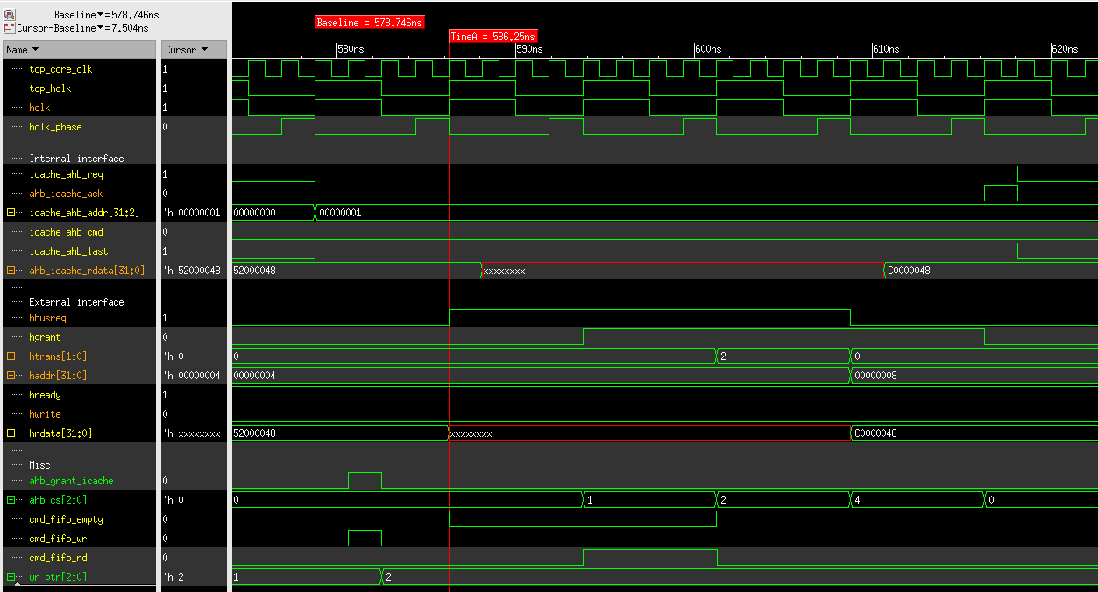
Case 2:
- frequency ratio: CPU:AHB = 4:1, BIU asynchronous mode
- Total latency from cache_ahb_req to ahb_cache_ack = (9 hclk cycles) ~ (2 cpu cycles + 9 hclk cycles)
* The range is because of cross-clock domain. The difference may be included in the hclk cycle.
- overhead difference compared with sync mode is about 4 hclk cycles
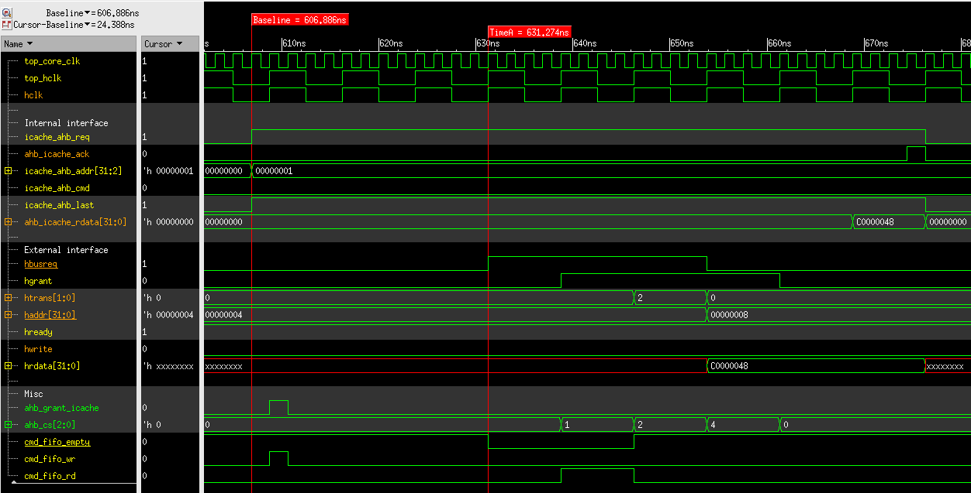
Case 3:
- frequency ratio: CPU:AHB = 1:1, BIU synchronous mode
- Total latency = 8 cycles
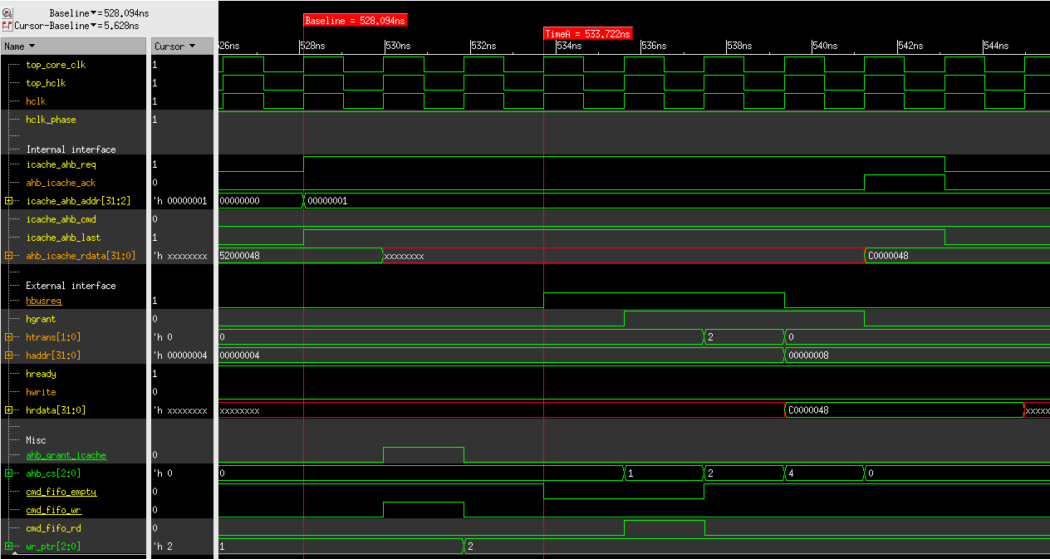

Case 4:
- frequency ratio: CPU:AHB = 1:1, BIU asynchronous mode
- Total latency = 14 cycles (overhead difference compared with sync mode is 6 cycles)
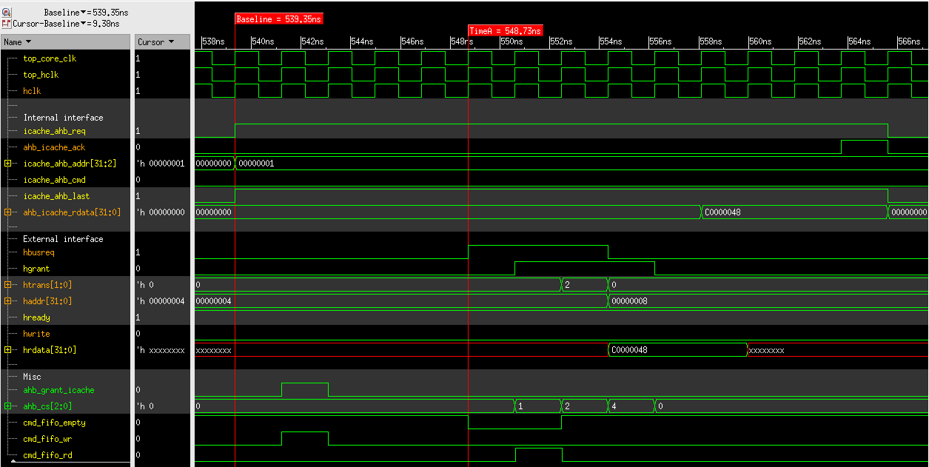

B. cacheable, but cache miss (burst request)
In both synchronous and asynchronous mode, the first request is the same as section A. Other 7 requests of the burst only consume 1 hclk cycle per request. Therefore, the overhead difference between two modes is diluted.

